**How to join a distributed key searching job in the CrypCloud**

First, click on the CrypCloud icon (“Connect”) in the CT2 ribbon bar:

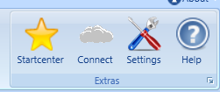

After that, enter your login credentials:

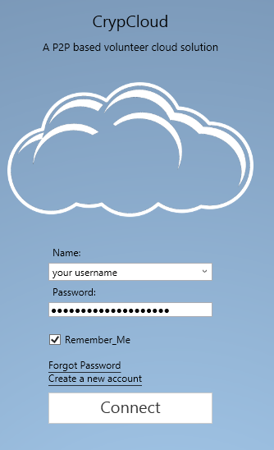

You can select “Remember Me” if you use your own computer. Your credentials will be stored encrypted with the current windows password in a special password file in the application data of CrypTool 2. If CrypTool 2 should remember you, the login data is auto filled into the fields. If it is your first login, your user certificate will be automatically downloaded into the application data folder of CrypTool 2. Your certificate is encrypted with your password.

Click the “Connect” button to connect to the CrypCloud.

After the login, you will see a list of distributed CrypTool 2 workspaces:

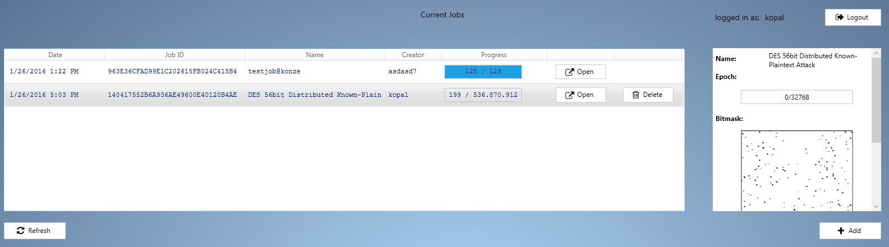

On the right side of each job, you can download the corresponding workspace. After downloading a workspace, you can click “Open”.

After opening the workspace, you should, for example, see a DES key searching workspace like this:

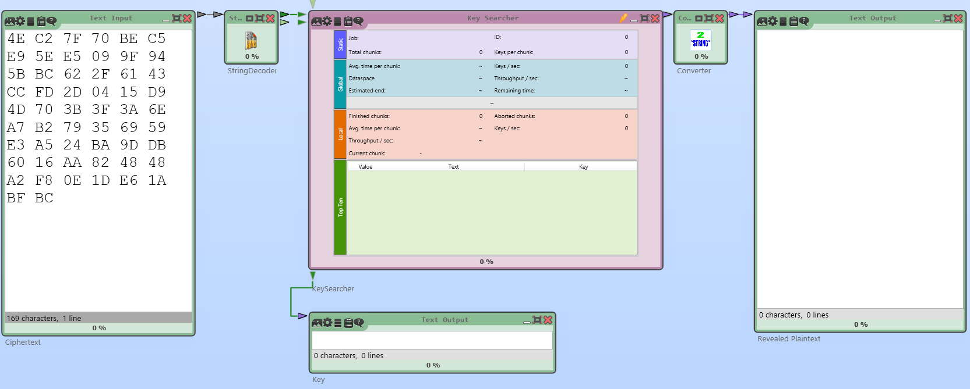

Just click play  and you automatically join the distributed computing job.The key searcher shows some interesting statistics during the execution:

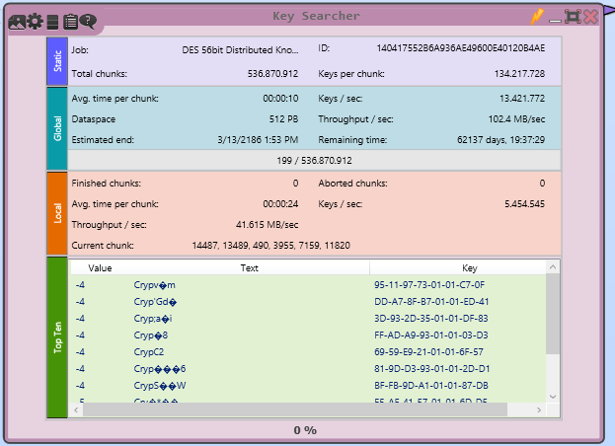

If you want to change the amount of workers (threads) that CrypTool 2 may use for the distributed computing, go to the settings:



Here, select “Main/CrypCloud settings”:

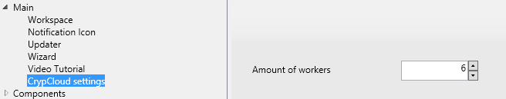

Here, you can change the “Amount of workers”.

If you want to have CrypTool 2 being executed in the “background” without disturbing your daily work or gaming, you can change the priority of the CrypTool 2 application by right clicking on the CrypTool 2 tray icon on the right side of your taskbar:

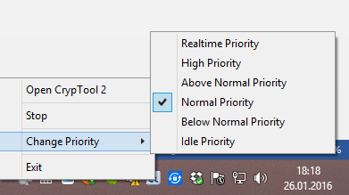

Just change the priority to “Idle Priority”.